Dr. R.J. Zende appointed as Technical Consultant/ Expert for Food Safety by World Health Organization
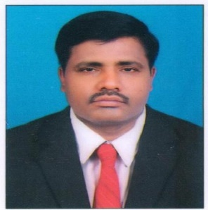
Dr. R.J. Zende, Professor and University Head, Department of Veterinary Public Health, Mumbai Veterinary College has been recently appointed by World Health Organization as Technical Consultant/ Expert for Food Safety for consultancy assignments which may arises from time to time in South East Asia Region. As an Expert Member of Advisory group, “Foodborne Disease Burden Epidemiology Reference Group (FERG).” Dr. Zende will be actively involved in advising WHO on development of methodology to estimate the global burden of food borne diseases, reviewing epidemiological data, identifying Technical gaps and priorities for Research activities, development of methodology to monitor Food Safety related indicators and making recommendations to WHO on the establishment of Task forces and other means through which Scientific and Technical matters have been adequately addressed for the benefit of South East Asia Region. The work duration is of three years with effective from 22 March, 2021. Earlier Col. (Dr.) Prof. A. M. Paturkar, Hon’ble Vice Chancellor, Maharashtra Animal and Fishery Sciences University, Nagpur was also nominated by World Health Organization as an Expert Review Member for formulating standards on antimicrobial residues of animal origin foods.
On Dr. Zende’s recognition by World Health Organization Col. (Dr.) Prof. A. M. Paturkar, Hon’ble Vice Chancellor, Maharashtra Animal and Fishery Sciences University, Nagpur, Dr. A.P. Somkuwar, Director of Instruction and Dean, Faculty of Veterinary Science, Dr. N.V. Kurkure, Director of Research and Dr. A.S. Ranade, Associate Dean, Mumbai Veterinary College are truly proud for Dr. Zende’s accomplishment for bringing MAFSU and Mumbai Veterinary College into a global engagement to address food safety.

